Assignment 1

Network commands

* **Ping**

you can check the data packets sent and received by the server and is there any data loss during the transmission.

C://ping www.gmail.com

C://ping www.yahoo.com

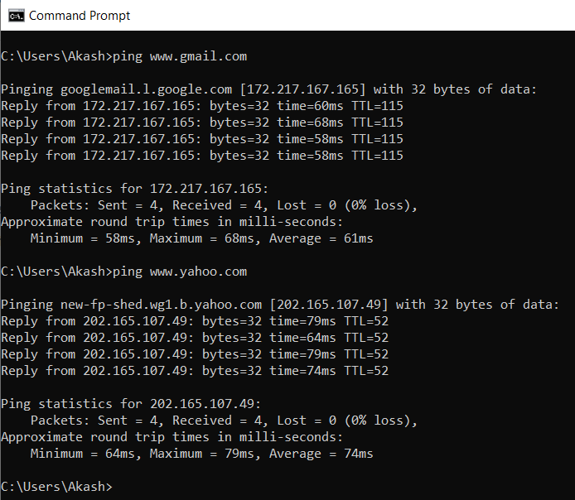

* **Tracert/Traceroute**

No of hops made by the source to destination, list all the IP address

**Hops**: In computer networks, a hop is an intermediate connection in a string of connections linking two devices. Whenever a router or gateway is an intermediary device between two different and remote hosts, nodes or networks, it is known as a hop..

C://tracert www.gmail.com

C://tracert [www.newhorizonindia.edu](http://www.newhorizonindia.edu)

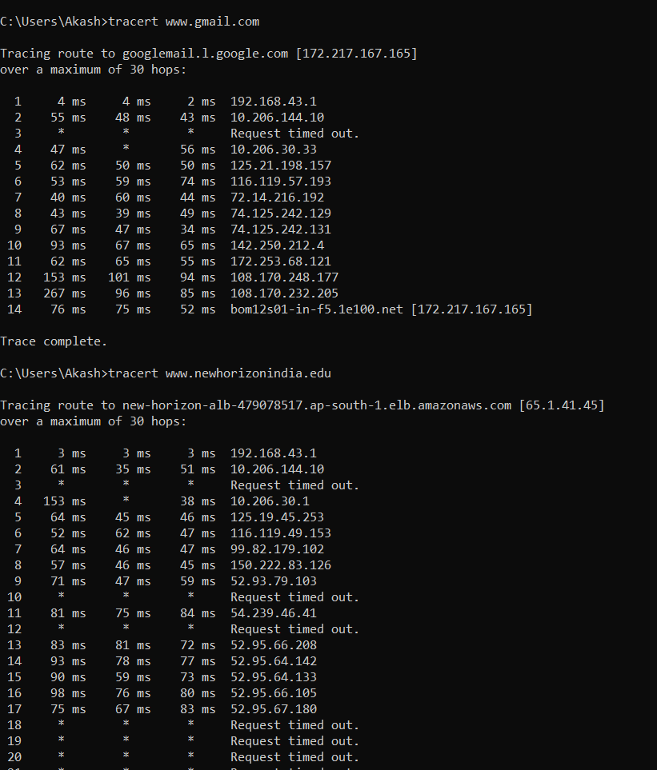

* **Telnet**

It is a protocol that provides a command line interface for communication with a remote device or server, sometimes employed for remote management but also for initial device setup like network hardware.

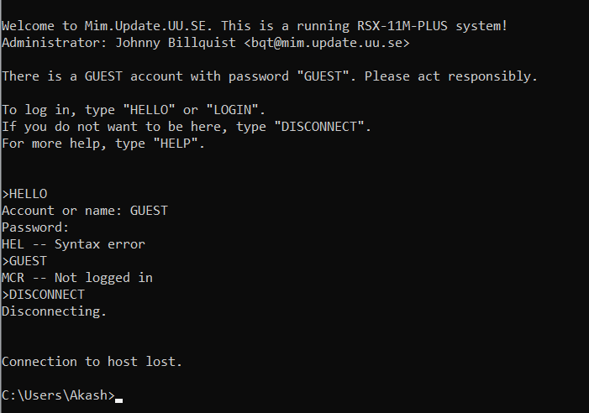

* **Nslookup**

The NsLookup tool allows you to query DNS servers for resource records. It is used for troubleshooting DNS related problems.

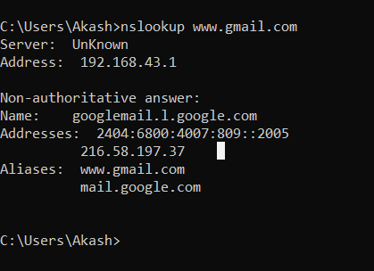

* **IPCONFIG, IPCONFIG/ALL**

FIND MAC ADDRESS AND IPV4 AND IPV6 ADDRESS OF YOUR COMPUTER

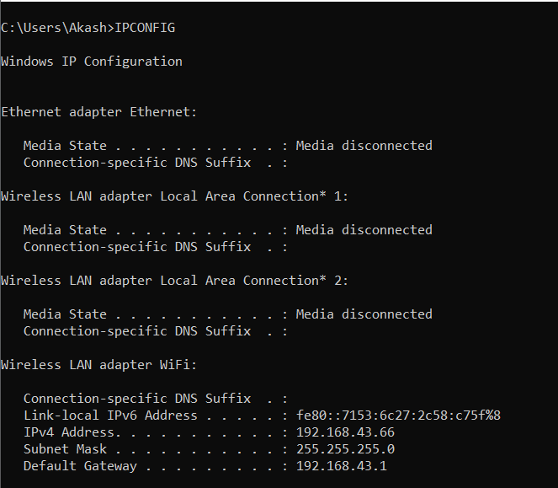

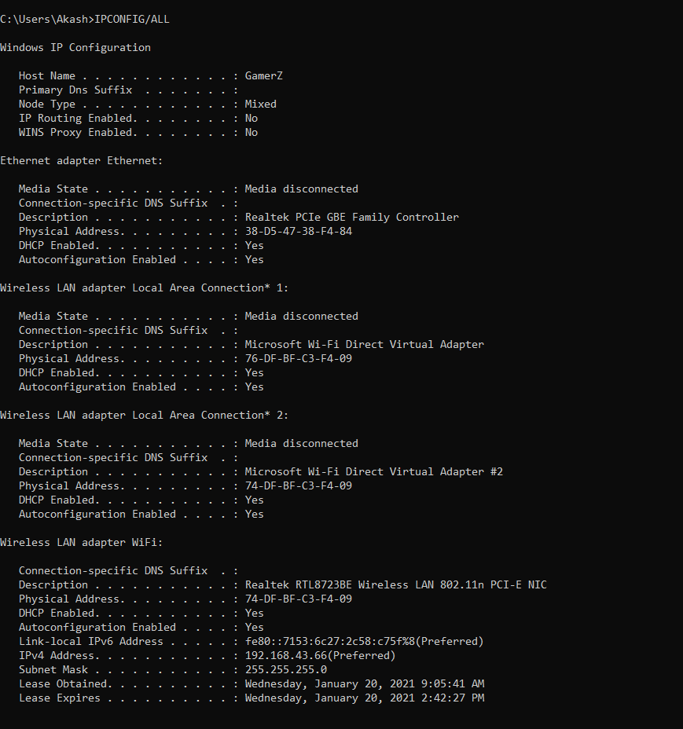

* **HOSTNAME**

To find host name of your computer

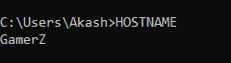

* **Netstart –a**

The net start command is used to start a network service or list running network services.

